Lab Assignment #2
Cryptography

Steffen L. Norgren <ironix@trollop.org>
A00683006

COMP 7615 • BCIT • September 28, 2009

Table of Contents
Purpose 3
Procedures 3
Texts Used 3
Step #1 - Open Texts 3
Step #2 - Produce Histograms of Unencrypted Texts 4
Step #3 – Encrypt Texts 4
Step #4 – Produce Histograms of Encrypted Texts 5
Histogram for Unencrypted Text #1 6
Histogram for Unencrypted Text #2 6
Histogram for Unencrypted Text #3 7
Histogram for Encrypted Text #1 7
Histogram for Encrypted Text #2 8
Histogram for Encrypted Text #3 8
Discussion 9
Conclusion 9

Purpose
To create and analyse histograms of the character distribution in unencrypted and encrypted texts. Through such analysis of character frequency, one should be able to easily determine a method of decryption for texts that were encrypted using a simple cipher, such as the Caesar cipher.

Procedures

Texts Used
- Text #1 – Astounding Stories of Super-Science, February 1930:
http://www.gutenberg.org/ebooks/28617
- Text #2 – Astounding Stories of Super-Science, March 1930:
http://www.gutenberg.org/ebooks/29607
- Text #3 – Astounding Stories of Super-Science, April 1930:
http://www.gutenberg.org/ebooks/29390

Step #1 - Open Texts
Open the reference texts.
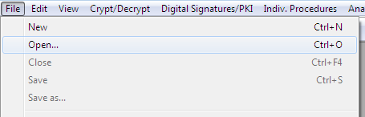

Step #2 - Produce Histograms of Unencrypted Texts
For all three texts, produce a histogram of the character frequency.
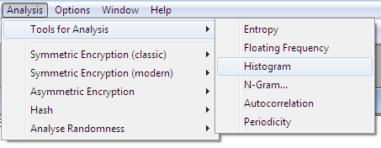

Step #3 – Encrypt Texts
Encrypt all three texts using the Caesar cipher.
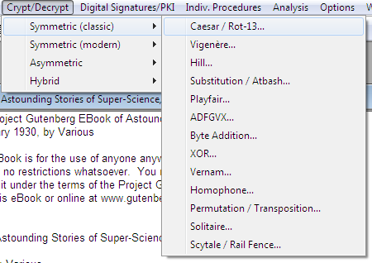
Select any letter except A as the encryption key.
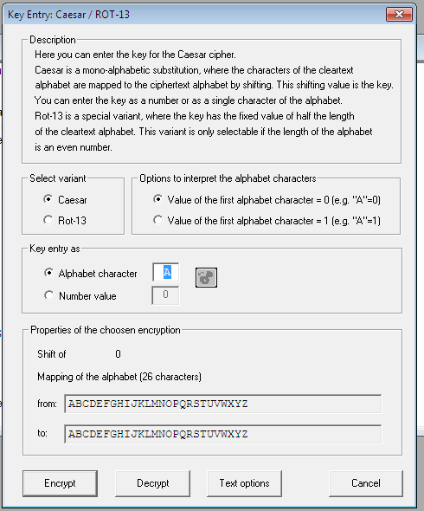

Step #4 – Produce Histograms of Encrypted Texts
For all three encrypted texts, produce a histogram of the character frequency.

Histogram for Unencrypted Text #1
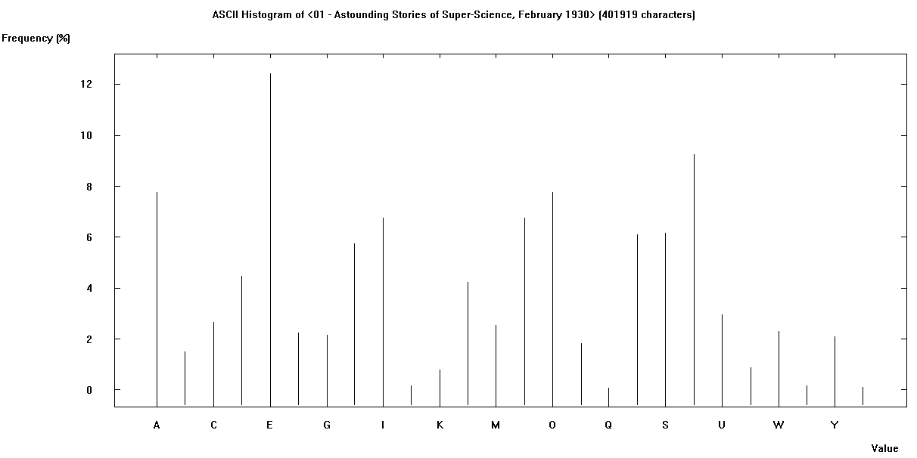

Histogram for Unencrypted Text #2
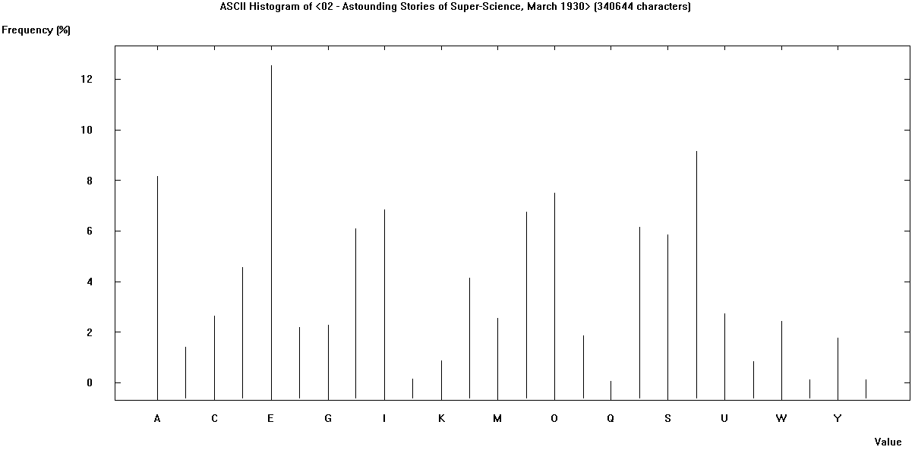

Histogram for Unencrypted Text #3
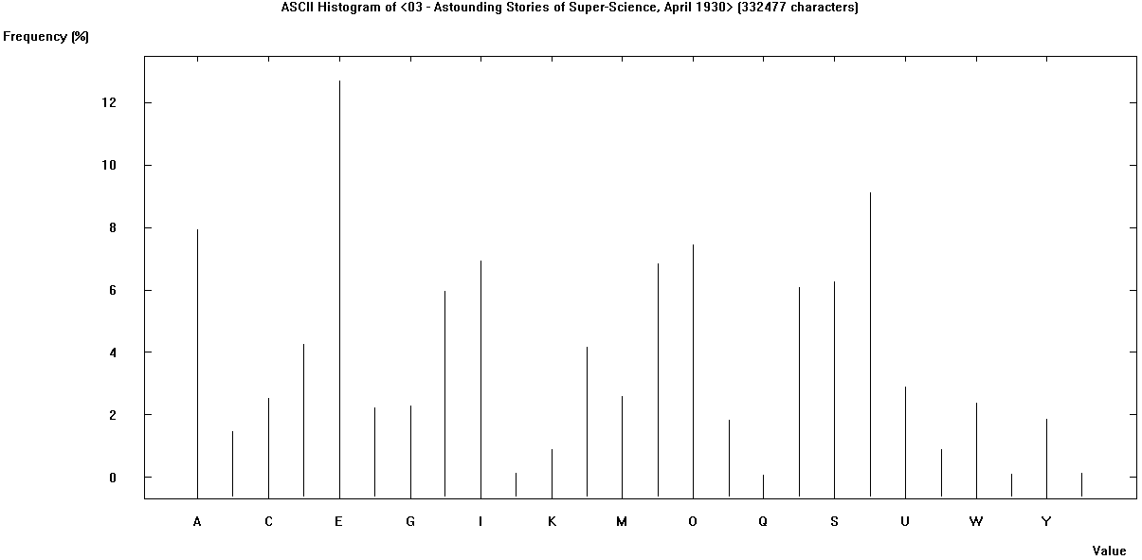

Histogram for Encrypted Text #1
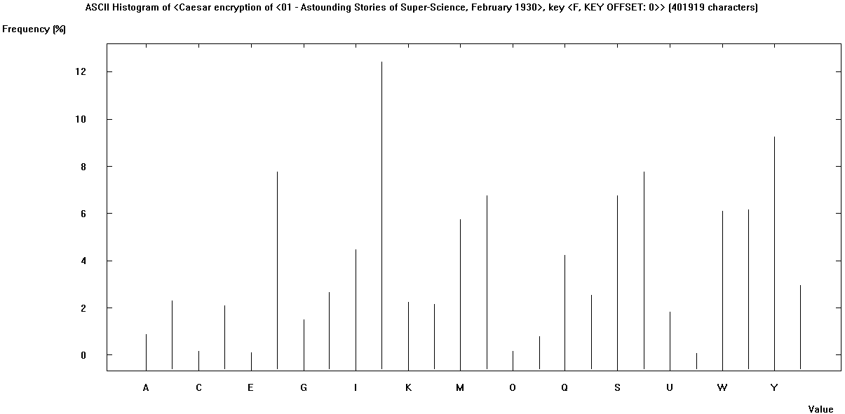

Histogram for Encrypted Text #2
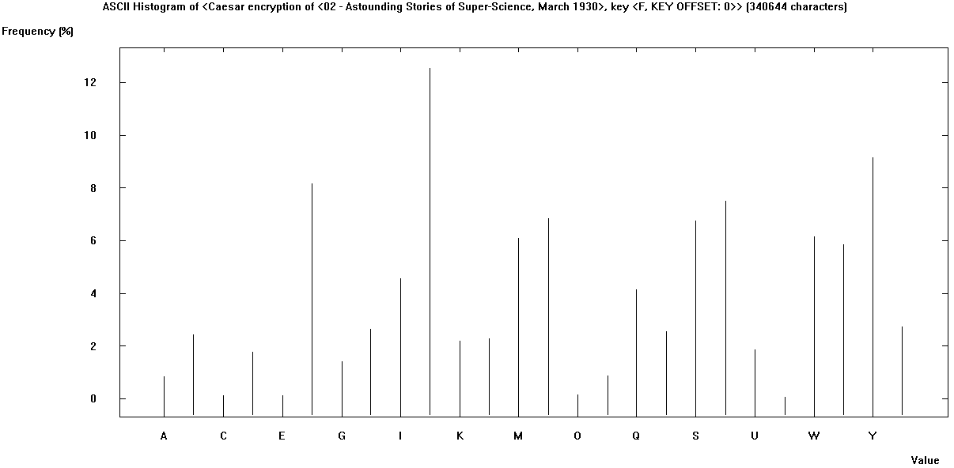

Histogram for Encrypted Text #3
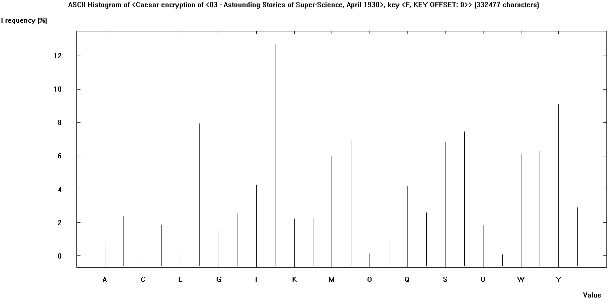

Discussion
Comparison of the unencrypted and encrypted character frequency histograms, one can easily make out patterns common to each text. The histograms for each unencrypted text are very similar with only a few minor variations, this is also true for the histograms of the encrypted texts. However, once you compare the histograms for an unencrypted and encrypted text, one can easily see that they are in fact the same histogram, only shifted to the left or right depending on what cipher key was used.

Conclusion
Through analysis of the unencrypted and encrypted histograms, one can easily discover the cipher used in each case by simply shifting the encrypted histogram over to the left or right until they both match.

